PIZZA SALES DATASET SQL QUERIES
- KPI’s
- Total Revenue:
SELECT
SUM(total_price) AS Total_Revenue
FROM [Pizza Sales Dataset];
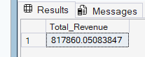
- Average Order value:
SELECT
SUM(total_price) / COUNT(DISTINCT(order_id)) AS Average_Order_Value
FROM [Pizza Sales Dataset];
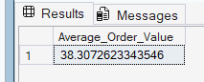
- Total Pizzas Sold:
SELECT
SUM(quantity) AS Total_Pizzas_Sold
FROM [Pizza Sales Dataset];
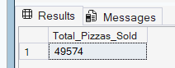
- Total Orders:
SELECT
COUNT(DISTINCT(order_id)) AS Total_Orders
FROM [Pizza Sales Dataset];
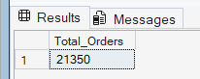
- Average Pizzas Per Order:
SELECT
CAST(
CAST(SUM(quantity) AS DECIMAL) /
CAST(COUNT(DISTINCT(order_id))AS DECIMAL)
AS DECIMAL(10,2)) AS Average_Pizzas_Per_Order
FROM [Pizza Sales Dataset];
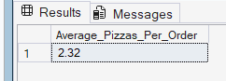
- CHARTS REQUIREMENTS:
- Daily Trend of Total Orders:
SELECT
order_day,
COUNT(DISTINCT(order_id)) AS Total_orders
FROM [Pizza Sales Dataset]
GROUP BY order_day;
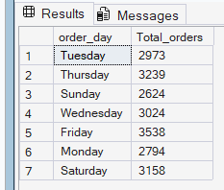

- Hourly Trend of Total Orders:
SELECT
DATEPART(HOUR,order_time) AS Order_Hour,
COUNT(DISTINCT(order_id)) AS Total_orders
FROM [Pizza Sales Dataset]
GROUP BY DATEPART(HOUR,order_time)
ORDER BY DATEPART(HOUR,order_time);
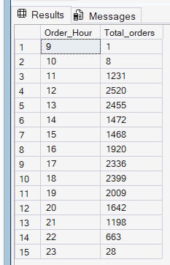

- Percentage Of Sales By Pizza Category:
SELECT
pizza_category,
ROUND(SUM(total_price),0 ) AS Total_sales ,
ROUND((SUM(total_price)/ SUM(SUM(total_price)) OVER())*100,2) AS "Percentage_Of_Sales"
FROM [Pizza Sales Dataset]
GROUP BY pizza_category
ORDER BY "Percentage_Of_Sales" DESC;
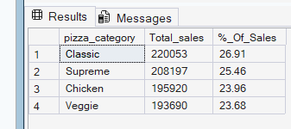
- Percentage Of Sales By Pizza Size:
SELECT
pizza_size,
CAST(
SUM(total_price)
AS DECIMAL(10, 0)
) AS Total_sales ,
CAST(
SUM(total_price) * 100
/ SUM(SUM(Total_price)) OVER()
AS DECIMAL(10,2)
) AS "%_Of_Sales"
FROM [Pizza Sales Dataset]
GROUP BY pizza_size
ORDER BY "%_Of_Sales" DESC;
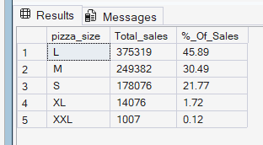

- Total Pizzas Sold By Pizza Category:
SELECT
pizza_category,
SUM(quantity) AS Total_Pizzas_Sold
FROM [Pizza Sales Dataset]
GROUP BY pizza_category;
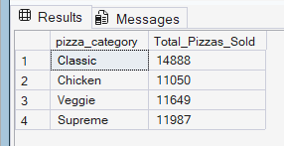
- Top 5 Best Sellers by Total Pizzas Sold:
SELECT TOP 5
pizza_name,
SUM(quantity) AS Total_Pizzas_Sold
FROM [Pizza Sales Dataset]
GROUP BY pizza_name
ORDER BY SUM(quantity) DESC;
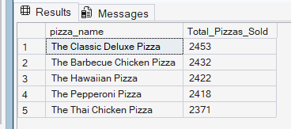
- Top 5 Worst Sellers by Total Pizzas Sold:
SELECT TOP 5
pizza_name,
SUM(quantity) AS Total_Pizzas_Sold
FROM [Pizza Sales Dataset]
GROUP BY pizza_name
ORDER BY SUM(quantity) ASC;
